Name: Saurabh Sanjay jadhav

Topic : Jenkins public and private repository.

Assignment no. : 20

1. Login to Jenkins

<public-ip>:8080

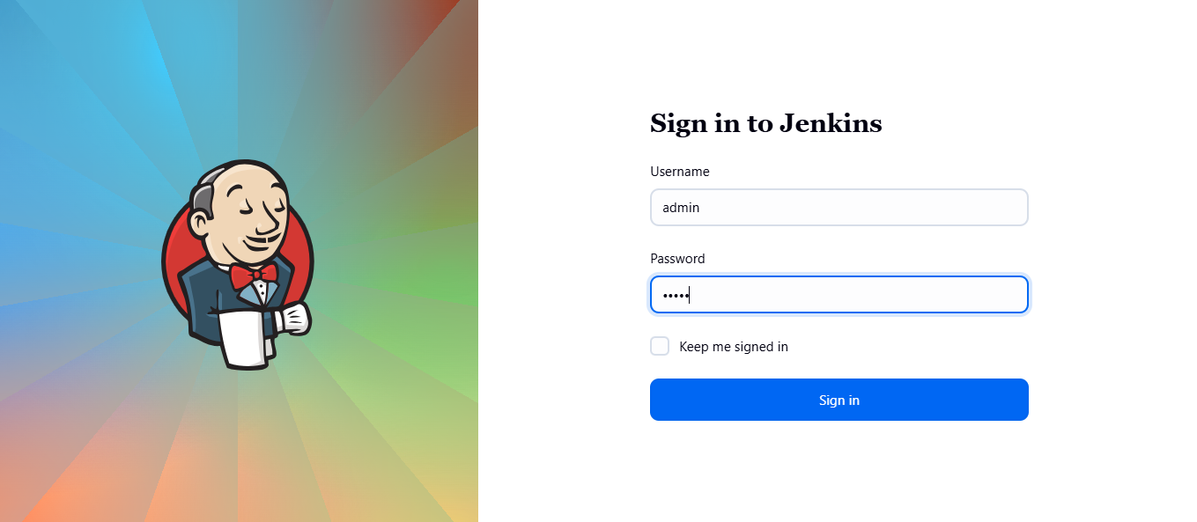

1. Create a job to create folder and files.
2. Name of job “1st_job” and select job type as freestyle project.

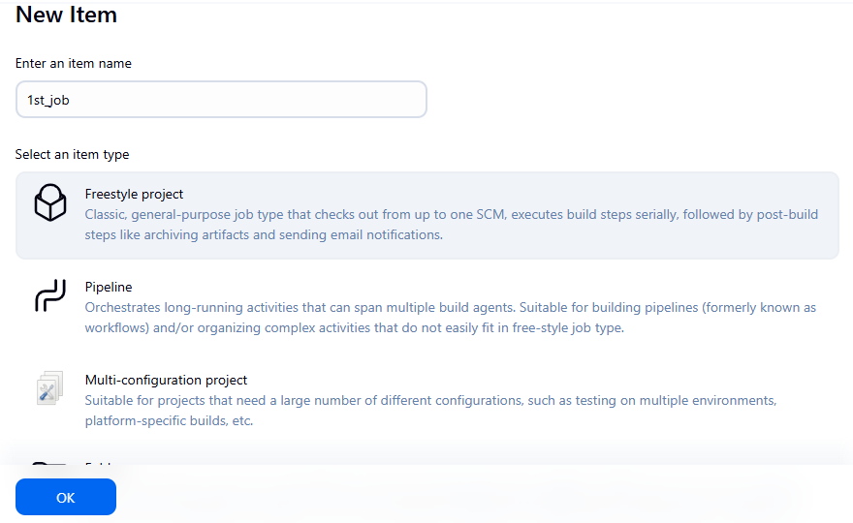

1. Configure the job.

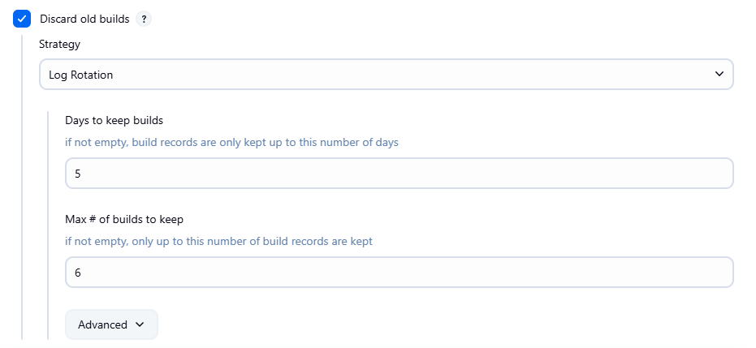

1. Job created successfully

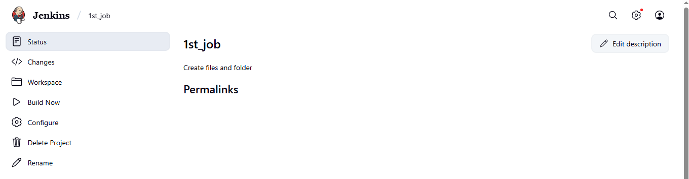

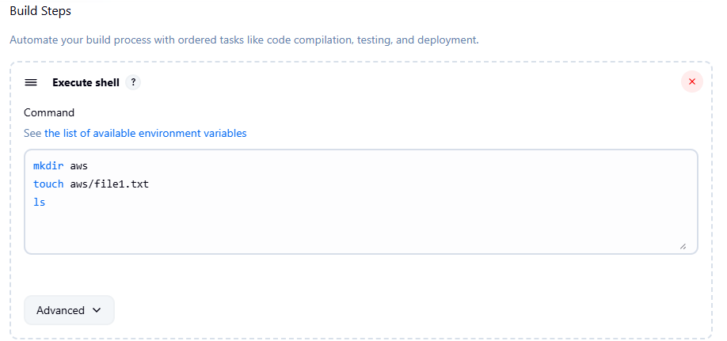

1. Build successfully.

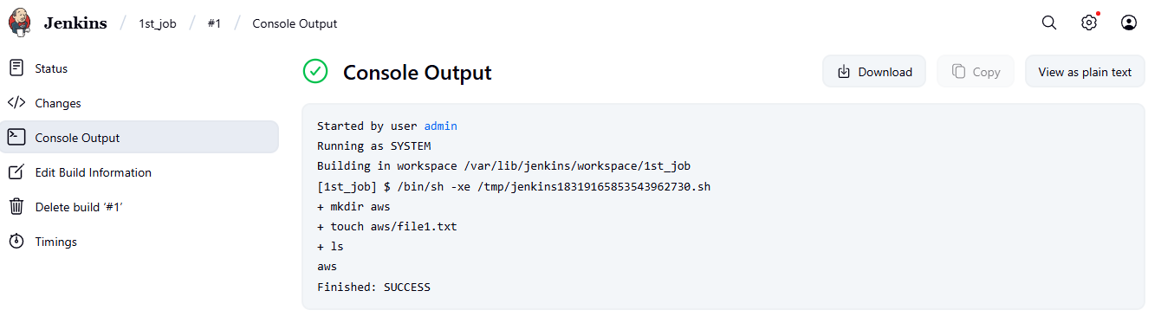

1. Job successful completed in instance.

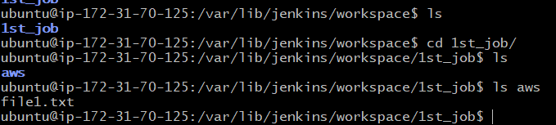

1. Create a job to clone private repo.
2. Name of job “2nd_pub_repo”

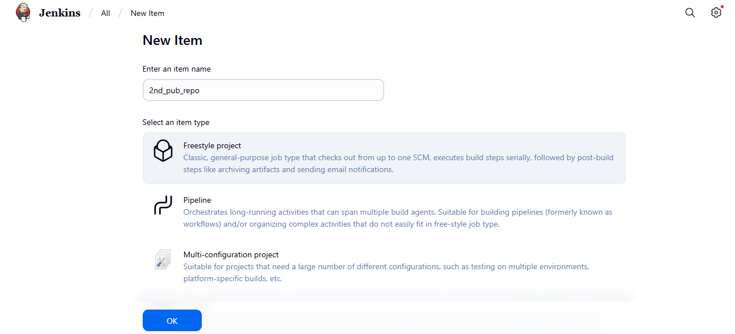

1. Create access token in github.

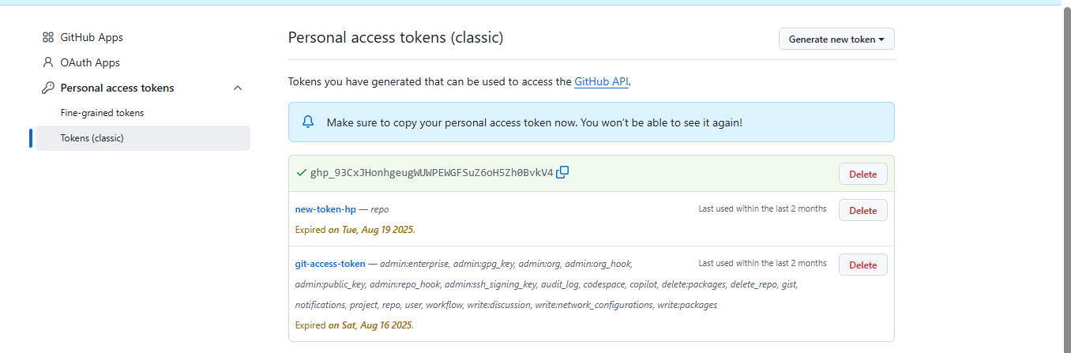

1. Provide the credentials in jekins for github.

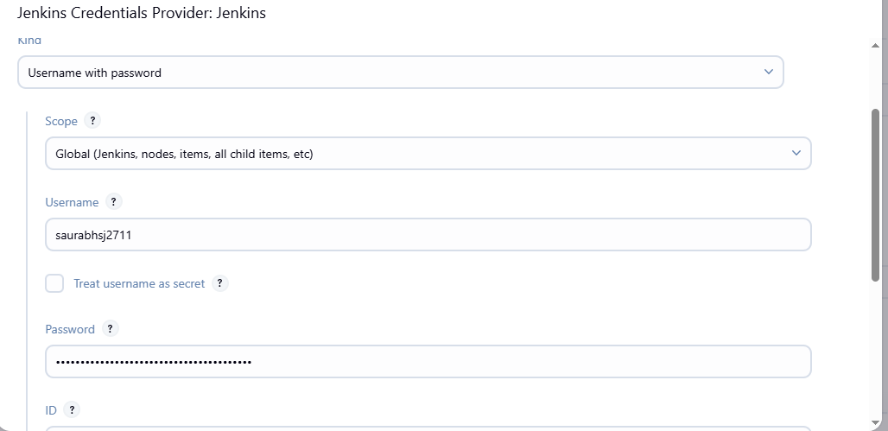

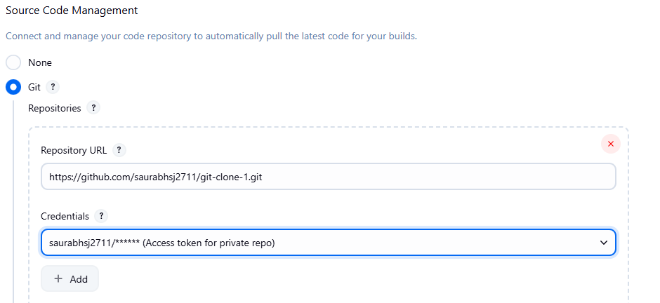

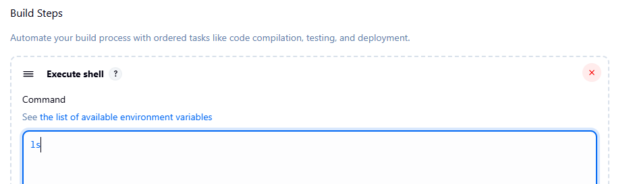

1. Successfully build the job.

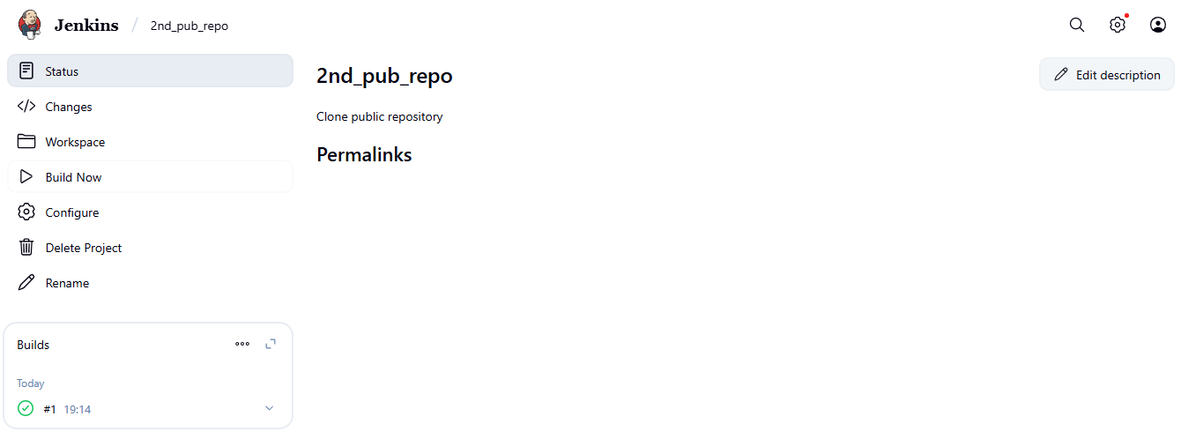

1. Console output

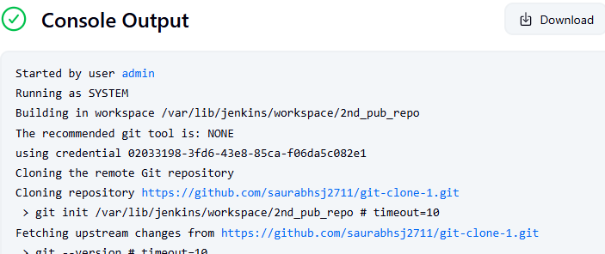

1. Successfully job completed.

